PRESS RELEASE for October 2, 2007

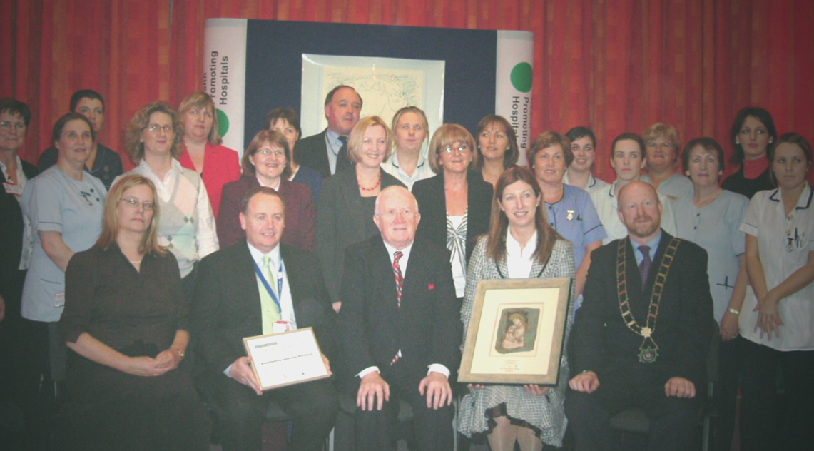

Our Lady of Lourdes Hospital receives Baby Friendly Hospital Award

One-third of births take place in the six Irish maternity services that meet the WHO/UNICEF criteria to be designated a baby-friendly hospital. This percentage is higher than Spain, Germany and France and similar to that of the UK though behind the Scandinavian and Dutch rates. The target in the National Breastfeeding Action Plan is for 50% of births to be in baby-friendly hospitals by 2010, so still some work to do. In 2006 approximately 30,000 newborn babies left Irish hospitals breastfeeding, giving them a healthy start in life as well as health and economic benefits for their mothers and families.

The latest hospital to join this elite group of designated baby-friendly hospitals is Our Lady of Lourdes Hospital, Drogheda. Baby-friendly hospitals also facilitate their staff continuing to breastfeed after returning to work through a supportive environment with breastfeeding facilities as well as lactation breaks. Our Lady of Lourdes Hospital also received a Silver award of Breastfeeding Supportive Workplace.

The awards were presented on October 2nd by Mr Pat “The Cope” Gallagher, TD, Minister of State at the Department of Health and Children.

Accepting the Baby Friendly Hospital Award, Eileen Whelan, Director of Nursing & Midwifery said ‘it is an honour to accept this very prestigious award which indicates the international standards of excellence achieved at Our Lady of Lourdes Hospital through a multidisciplinary approach’

The Baby Friendly Hospital Initiative recognises that implementing best practice in the maternity service is crucial to the success of programmes to promote and support breastfeeding. Reaching the standard means the maternity service develops a policy, provides training for staff, promotes informed parental choice through the provision of appropriate, accurate and unbiased discussions, as well as implementing practices supportive of good mother and baby care. Hospitals are required to keep up these standards through annual audits and regular external assessments.

The initiative involves health-promoting practices and so is ideally linked with the objectives of the Health Promoting Hospitals Network, the co-ordinating authority for the Baby Friendly Hospital Initiative (BFHI) in Ireland.

Over 19,000 hospitals worldwide and 300 hospitals in the European Union have received Baby Friendly status. The other Irish hospitals to reach this standard are Portiuncula Hospital, Ballinasloe, Co. Galway, Waterford Regional Hospital, St Minchin’s Regional Maternity Hospital, Limerick, Rotunda Hospital, Dublin and the maternity services of University College Hospital, Galway.
The criteria for the Silver level Breastfeeding Supportive Workplace award go beyond the requirements of the legislation on lactation breaks and as well as facilities and time include that all staff in the organisation are aware of the importance of breastfeeding and how they can support colleagues who are breastfeeding.

Contacts:
Visit the web site of the Baby Friendly hospital Initiative in Ireland at www.ihph.ie/babyfriendlyinitiative
Genevieve Becker, National Co-ordinator of the Baby Friendly Hospital Initiative in Ireland bfhi@iol.ie Tel: 087-2318775
Specific to Our Lady of Lourdes Hospital
Rosaleen Harlin
Area Communications Manager Dublin North East
Tel: 046 9280576/ 087 8291416 Rosaleen.Harlin@maile.hse.ie

