PRESS RELEASE for April 1, 2008

Minister Brendan Smith Presents Baby Friendly Award to Cavan Hospital
Minister for Children and Cavan/Monaghan Deputy, Brendan Smith presented the Baby Friendly National award to Cavan Hospital. Congratulating Cavan Hospital on joining an elite group of designated Baby-Friendly hospitals, Minister Smith noted that 40% of births take place in the seven Irish maternity services that meet the WHO/UNICEF criteria to be designated a Baby-Friendly hospital. “This percentage is higher than Spain, Germany and France and similar to that of the UK though behind the Scandinavian and Dutch rates. The target in the National Breastfeeding Action Plan is for 50% of births to be in baby-friendly hospitals by 2010, so getting nearer. In 2007 approximately 30,000 newborn babies left Irish hospitals breastfeeding, giving them a healthy start in life as well as health and economic benefits for their mothers and families”, he said.

Baby-friendly hospitals also facilitate their staff continuing to breastfeed after returning to work through a supportive environment with breastfeeding facilities as well as lactation breaks. Cavan Hospital also received a Bronze award of a Breastfeeding Supportive Workplace.

Accepting the Baby Friendly Hospital Award, Eddie Byrne, Director of Nursing and Midwifery, Cavan Monaghan Hospital Group said ‘it is an honour to accept this very prestigious award which indicates the international standards of excellence achieved at Cavan General Hospital through a multidisciplinary approach.’

Ms Melanie Verwoerd, Executive Director of UNICEF Ireland’s presence at the event marks the links between mothers and babies and those who care for them, in all parts of the world.

This initiative involves health-promoting practices and so is ideally linked with the objectives of the Health Promoting Hospitals Network, the co-ordinating authority for the Baby Friendly Hospital Initiative (BFHI) in Ireland.

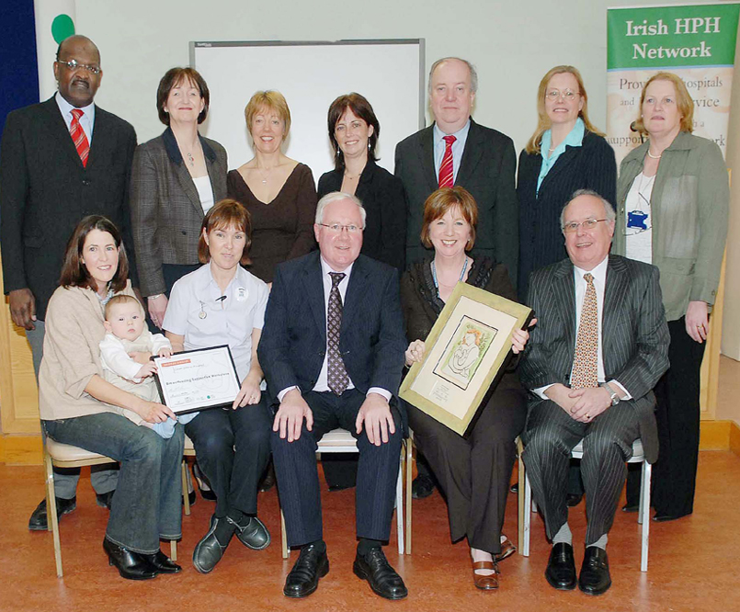
Presentation of BFHI awards Cavan Hospital, April 1st, 2008

